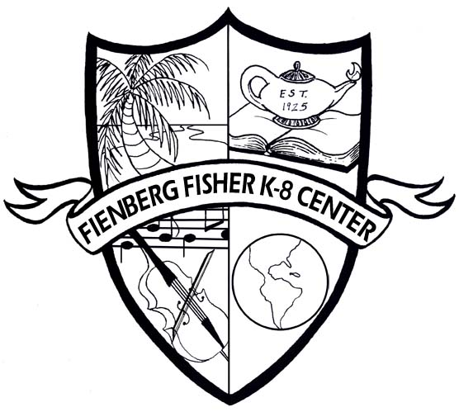

Fienberg-Fisher K-8 Center
IB World School

2013
Summer Home Learning Packet
for
Incoming First Grade Students

Dear Parents/Guardians:

Over the summer, all students are required to read at least two books and complete the activities attached with this packet. When the students return to school, they will be required to turn in the packet to their teacher. This will be their first two grades for the first nine weeks.

Required Reading with Activities:
Curious George Visits the Zoo / Author: H.A. Rey (IB)
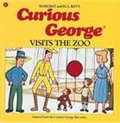

If You Give A Mouse A Cookie/ Author: Laura J. Numberoff
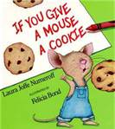

Recommended Reading:

Very Hungry Caterpillar The Little Red Hen The Mitten
Author: Eric Carle Author: Byron Barton Author: Jan Brett
